APPLECROSS SENIOR HIGH SCHOOL
3A/3B HUMAN BIOLOGOLGICAL SCIENCES
TEST 3: NERVOUS SYSTEM

DO NOT MARK THIS PAPER IN ANY WAY

Time Allowed: All Period

PART A. Answer questions 1 to 30 on the multiple choice answer sheet provided by marking the letter corresponding to the BEST alternative

- The part of the nervous system which produces the “fight or flight” response is the
a) central nervous system
b) parasympathetic system
c) peripheral nervous system
d) sympathetic system
- Which of the following symptoms would a person with a degenerative disease of the cerebellum be most likely to show?
a) Loss of peripheral vision
b) Reduced motor co-ordination
c) Difficulty hearing high pitched sounds
d) Loss of long term memory
- The regulation of breathing and heart rate involves neurons cell bodies that lie in the:
a) cerebrum
b) spinal cord
c) medulla
d) thalamus
4. The following is a list of structures in the body that may detect stimuli.
i. semicircular canals of the inner ear
ii. stretch receptors in the joints
iii. retina of the eyes
iv. baroreceptors in blood vessels
v. pain receptors in the skin
vi. pressure receptors in the skin

Which of these structures send information to the brain to assist in the maintenance of
balance and posture?
a) i, ii, iii and vi
b) i, ii, iv and vi
c) ii, iv and v
d) i, iii, iv and v

5. A student completing an examination experienced the following sequence of events:
i. he opened the first page of his examination paper
ii. his heart rate began to increase rapidly
iii. he began to write his first answers
iv. his heart rate decreased back to normal levels

Which of the following correctly links the events above to the branches of the nervous system that control them?

 | i | ii | iii | iv
a) | somatic | sympathetic | somatic | parasympathetic
b) | somatic | parasympathetic | somatic | sympathetic
c) | sympathetic | somatic | parasympathetic | somatic
d) | parasympathetic | somatic | sympathetic | somatic

6. A sensory neuron has its cell body located in:

a) gray matter of the spinal cord.
b) gray matter of the cerebrum.
c) white matter of the spinal cord.
d) a dorsal root ganglion.

7. A nerve fibre is a:

a) | bundle of axons.
b) | bundle of dendrites.
c) | motor nerve.
d) | cytoplasmic extension of a nerve cell body.

8. Consider the section of the brain illustrated below:
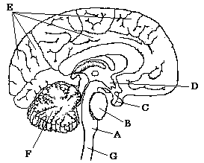

Which of the following is CORRECT?

a) D is the hypothalamus, F is the cerebral cortex and G is the spinal cord.
b) A is the medulla, B is the pons and F is the cerebellum.
c) B is the hypothalamus, C is the pituitary gland and E is the cerebrum.
d) Cis the hypothalamus, F is the cerebellum and G is the spinal cord.

9. Conscious control of muscular activity is carried out by the:

a) | cerebrum.
b) | cerebellum.
c) | medulla oblongata.
d) | skeletal muscles.

10. The autonomic nervous system is responsible for:
a) higher brain functions
b) co-ordination of muscular activity
c) involuntary control of our internal environment
d) voluntary control of respiration
11. Which of the structures labelled on the diagram below is responsible for conducting nervous impulses away from the cell body?
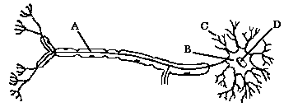
a) | A
b) | B
c) | C
d) | D

12. Which of the following statements BEST describes homeostasis?

a) Homeostasis maintains the core body temperature at a constant level.
b) Homeostatic mechanisms make the body relatively independent of external changes.
c) Thirst and hunger are homeostatic mechanisms.
d) Homeostasis ensures that cells always function at their optimum level.

13. Which of the following is the correct sequence of events and structures that are involved in a steady state control system?

a) Stimulus → effector → receptor → modulator → response → feedback
b) Stimulus → receptor → modulator → effector → response → feedback
c) Stimulus → response → receptor → modulator → effector → feedback
d) Feedback → stimulus → effector → modulator → receptor → response

14. Receptors are:

a) nerve centres in the spinal cord.
b) centres in the brain that receive nerve impulses.
c) specialised nervous tissue sensitive to changes in our surroundings.
d) nerves that conduct impulses within the central nervous system.
15. Myelination of a nerve fibre

a) causes a slower conduction of nerve impulses along the fibre.
b) prevents the nerve impulses from jumping along the fibre.
c) slows the fibre’s return to normal following conduction of an impulse.
d) speeds up the passage of nerve impulses along the fibre.

16. The point where a nervous impulse is transferred from a neuron to a muscle fibre is called the

a) synapse.
b) neurotransmitter.
c) Nodes of Ranvier
d) interneuron.

17. What are the correct labels for the boxes labelled (A) and (B)?

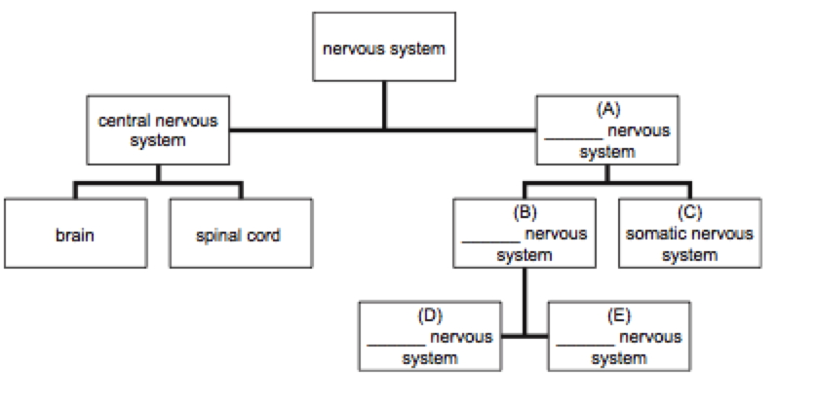
Figure 3. Nervous System divisions

a) sympathetic; parasympathetic
b) peripheral; autonomic
c) sympathetic; peripheral
d) parasympathetic; autonomic

18. The cerebral cortex

a) acts as a protective layer covering the brain.
b) connects the right hemisphere with the left hemisphere.
c) is responsible for voluntary muscle movements.
d) increases the strength of the immune system.

19. Which of the following statements about neurons is correct?

a) afferent neurons make the connection between motor and sensory neurons
b) efferent neurons make the connection between motor and sensory neurons
c) afferent neurons carry information from the sensory organs to the central nervous system
d) efferent neurons carry information from the sensory organs to the central nervous system

20. A spinal reflex is a

a) voluntary, stereotyped response to change.
b) protective, acquired behaviour.
c) rapid, involuntary response to a stimulus.
d) spontaneous response along a complex neural pathway.

21. When the sympathetic nervous system is activated, which of the following changes occur in the body?

a) the blood pressure decreases and the pupils dilate
b) the blood pressure increases and the pupils dilate
c) the blood pressure decreases and the pupils contract
d) the blood pressure increases and the pupils contract

22. Many nerve fibres consist of an axon and its myelin sheath. This myelin sheath:

a) | is responsible for the colour of the gray matter in the brain and spinal cord.
b) | is produced by Schwann cells located along the axon.
c) | is continuous all the way along the axon.
d) | all of the above.

23. Which of the following statements about the autonomic nervous system is correct? The autonomic nervous system:

a) affects the contraction rate of skeletal muscles.
b) affects the contraction rate of non-skeletal muscles.
c) is required to begin each contraction in skeletal muscles.
d) is required to begin each contraction in non-skeletal muscles.

24. Which of the following statements regarding membrane potentials is true?

a) An action potential is a brief reversal of charge across a cell membrane.
b) In a resting membrane potential the outside of the membrane is negatively charged compared to the inside.
c) Stimulation of a cell membrane results in sodium ion movement out of the cell.
d) all of the above

25. Given the following events:

1. acetylcholine broken down
2. acetylcholine moves across the synaptic cleft
3. action potential reaches the terminal branch (presynaptic terminal) of a motor neuron
4. acetylcholine combines with a receptor molecule on a skeletal muscle (postsynaptic membrane)
5. action potential produced in skeletal muscle cell

Choose the arrangement that lists the events in the order they occur at a neuromuscular junction.

a) 2, 3, 4, 1, 5
b) 3, 2, 4, 5, 1
c) 3, 4, 2, 1, 5
d) 4, 5, 2, 1, 3

Questions 26 ,27 and 28 refer to the diagram below.

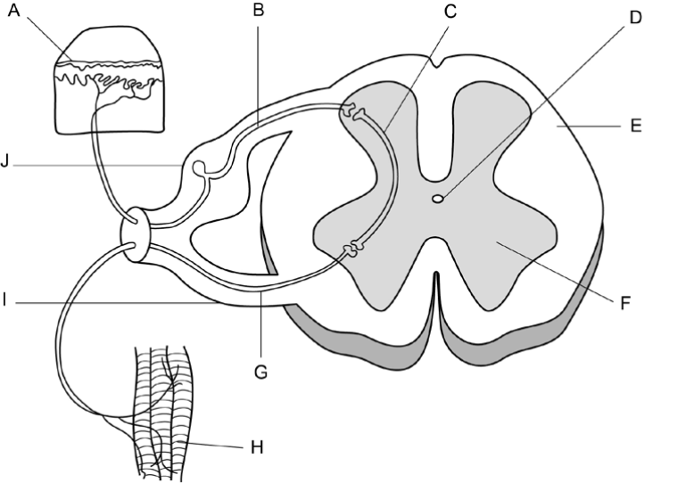

26. Which of the following statements correct?

a) A stimulus is detected by the receptors labelled ‘H’ and transmitted through the
sensory neuron labelled ‘G’.
b) The motor neuron is labelled ‘G’ and is located in the ventral root labelled ‘I’.
c) The interneuron is labelled ‘C’ and is located in the white matter labelled ‘F’.
d) A stimulus is detected by the receptors labelled ‘A’ and transmitted through the
motor neuron labelled ‘B’.

27. The neuron labelled ‘B’ in the diagram can be described as an
a) afferent neuron carrying information toward the spinal cord.
b) efferent neuron carrying information away from the spinal cord.
c) efferent neuron carrying information toward the spinal cord.
d) afferent neuron carrying information away from the spinal cord.

28. Structure D:

a) | contains blood vessels. |  | .
b) | contains nerves
c) | contains fluid.
d) | makes the spinal cord flexible.

Use the simplified diagram below of the nerve supply to a toe to answer questions 29 and 30

Lines A, B, C, and D show regions of the nervous system which might be blocked.
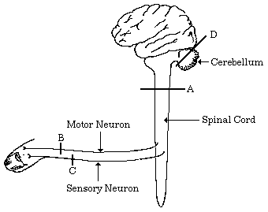

29. If the skin over the toe is stimulated and the stimulus can be felt but the toe cannot be moved then the block is at:

a) | A.
b) | B.
c) | C.
d) | D.
30. If the toe is stimulated it moves, but neither this movement nor the stimulation can be felt, then the block is at:

a) | A.
b) | B.
c) | C.
d) | D.

Name: ________________________________ Score: ______/20

APPLECROSS SENIOR HIGH SCHOOL
3A/3B HUMAN BIOLOGOLGICAL SCIENCES
TEST 3: NERVOUS SYSTEM

PART B: SHORT ANSWER

31. John was involved in a serious motorcycle accident. He failed to take a corner and was thrown head first into a brick retaining wall next to the road he was traveling on. In the hospital emergency department, it was noted that the right side of his brain had been damaged, as shown in the diagram.

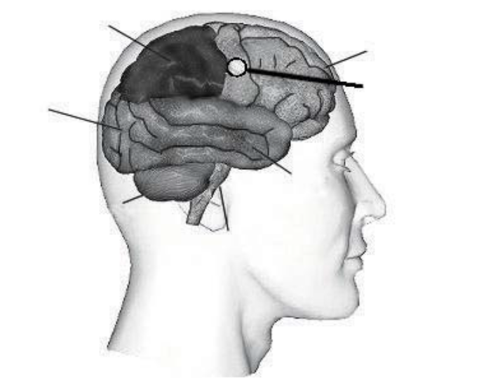
Parietal Lobe
Frontal Lobe

Occipital Lobe

Temporal Lobe

Cerebellum

(a) Describe the main function of the area indicated as the damaged zone of John’s brain. (1 mark)
______________________________________________________________________________

______________________________________________________________________________

(b) What general part of the body will this damage affect?

_______________________________________________________________________
(1 mark)
(c) Describe what the effect will be.

______________________________________________________________________________

(1 mark)

(d) During John’s examination, the neurologist used the terms ‘white matter’ and ‘grey
matter’. Distinguish between white and grey matter in terms of structure and location in the brain. (4 marks)

 | White matter | Grey matter
Structure

Location in the brain

(e) While in hospital, John was also diagnosed with Parkinson’s disease.

(i) State the effect of Parkinson’s disease on the brain. (1 mark)

______________________________________________________________________________

______________________________________________________________________________

(ii) Describe two (2) symptoms of Parkinson’s disease. (2 marks)

______________________________________________________________________________

______________________________________________________________________________

______________________________________________________________________________

______________________________________________________________________________

32. Figure 5 is a graph representing the electrical potential measured across a neuron’s membrane.
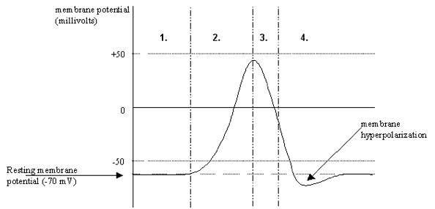
Figure 5. Membrane potential in a neuron.
Describe what is occurring at Stages 1 to 4.
______________________________________________________________________________

______________________________________________________________________________

______________________________________________________________________________

______________________________________________________________________________

______________________________________________________________________________

______________________________________________________________________________

______________________________________________________________________________

______________________________________________________________________________

______________________________________________________________________________

______________________________________________________________________________

______________________________________________________________________________

______________________________________________________________________________

(4 marks)

33. Identify the parts numbered 2 to 7 indicated in the diagram below and describe what is happening at that site.

2 _____________________________________________________________________________

______________________________________________________________________________

3. ____________________________________________________________________________

______________________________________________________________________________

4. ____________________________________________________________________________

______________________________________________________________________________

5. ____________________________________________________________________________

______________________________________________________________________________

6._____________________________________________________________________________

______________________________________________________________________________

7.____________________________________________________________________________

______________________________________________________________________________
(6 marks)

